Stop Calculating Commissions Manually: Automate Sales Incentives in Odoo 19
Rohan Raj — Infintor Solutions | March 2026
Every sales manager has seen it: a salesperson walks up, pulls up a spreadsheet, and says, “I think my commission is wrong.” What follows is 45 minutes of cross-referencing invoices, checking discount approvals, and recalculating slab rates. Multiply this by ten salespeople and four quarters, and you have a full-time job nobody signed up for.
Odoo 19’s Commissions module puts an end to this. It sits inside the Sales app, automatically tracking every invoice and sales order against predefined commission plans. Targets, tiers, flat rates, team targets, payroll integration — it handles the lot. This blog covers the complete setup, every configuration option, and practical examples for Indian businesses.

Step 1: Turn On Commissions
📂 Sales → Configuration → Settings → Invoicing → Enable Commissions → Save
Once enabled, the Sales app gets a new Commissions menu with:
- Commission Plans — create and manage your plans
- Commissions — view all calculated commissions (list, graph, pivot)
- My Commissions — each salesperson sees only their own data
Plus a Commissions report under Sales → Reporting for management dashboards.
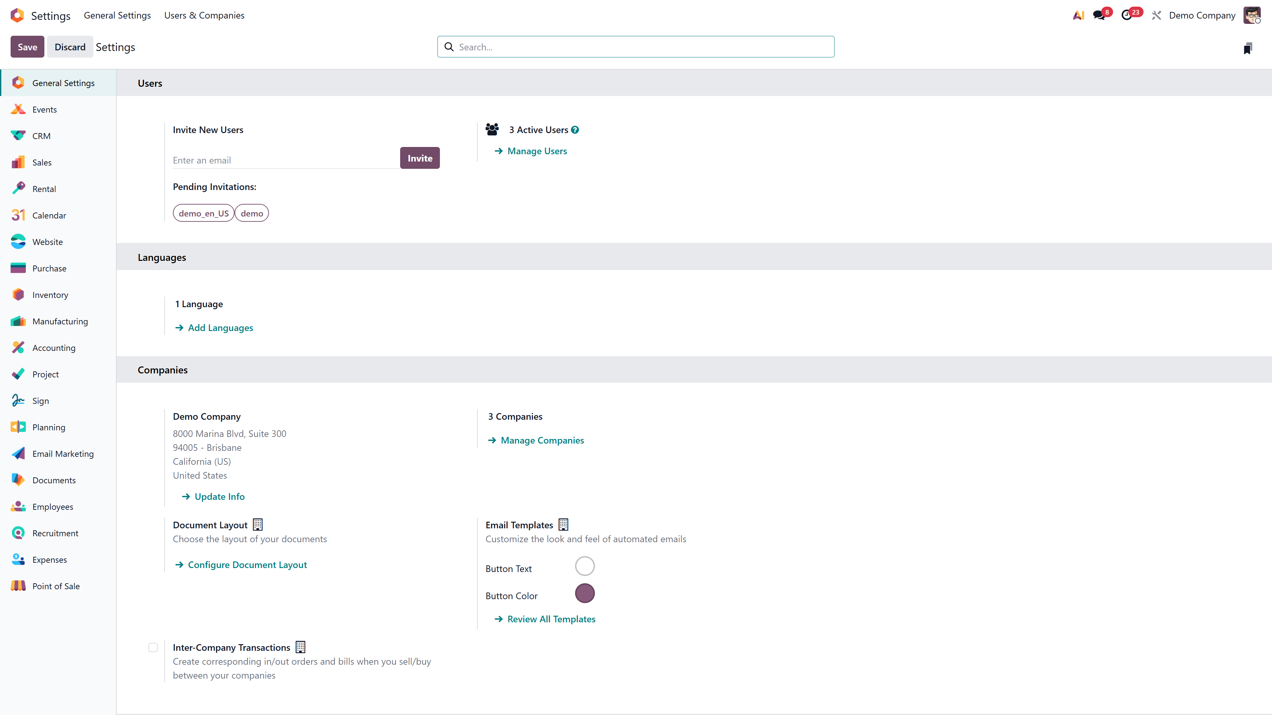
Sales Settings → Invoicing → Commissions enabled

Step 2: Choose Your Commission Strategy

Strategy A — Target-Based (“Hit this number, earn this reward”)
You set a sales target per period. The salesperson earns commission based on what percentage of the target they achieve. Add levels for tiered payouts.
ℹ️ Example: Salesperson Arun has a quarterly target of ₹5,00,000. At 100%, he earns ₹50,000. At 150%, ₹75,000. At 50%, ₹0 (or ₹15,000 if you configure a level there).
Best for: Companies with defined sales goals, seasonal targets, and performance tiers.

Strategy B — Achievement-Based (“Earn X% on everything you sell”)
Every qualifying invoice or sale order earns a flat percentage commission. No target. No tiers.
ℹ️ Example: Salesperson Priya earns 5% on every invoice. She invoices ₹3,00,000 in March — commission ₹15,000. She invoices ₹8,00,000 in April — commission ₹40,000.
Best for: Agent-based sales models, freelance distributors, or simple commission structures.

Step 3: Create the Plan
📂 Sales → Commissions → Commission Plans → New

The Form Fields

Field | Description | Notes
Name | Label for the plan | Use descriptive: “FY26 Quarterly Targets”
Based on | Targets or Achievements | Core plan type
per | Salesperson or Sales Team | Team plans require selecting a team
Commission Amount | Payout amount for achievements / OTC for targets | Default ₹1,000
From / To | Effective dates | Overall active period
Periodicity | Monthly / Quarterly / Yearly | Auto-generates periods
Sale team | (Team plans only) | Required when per = Sales Team

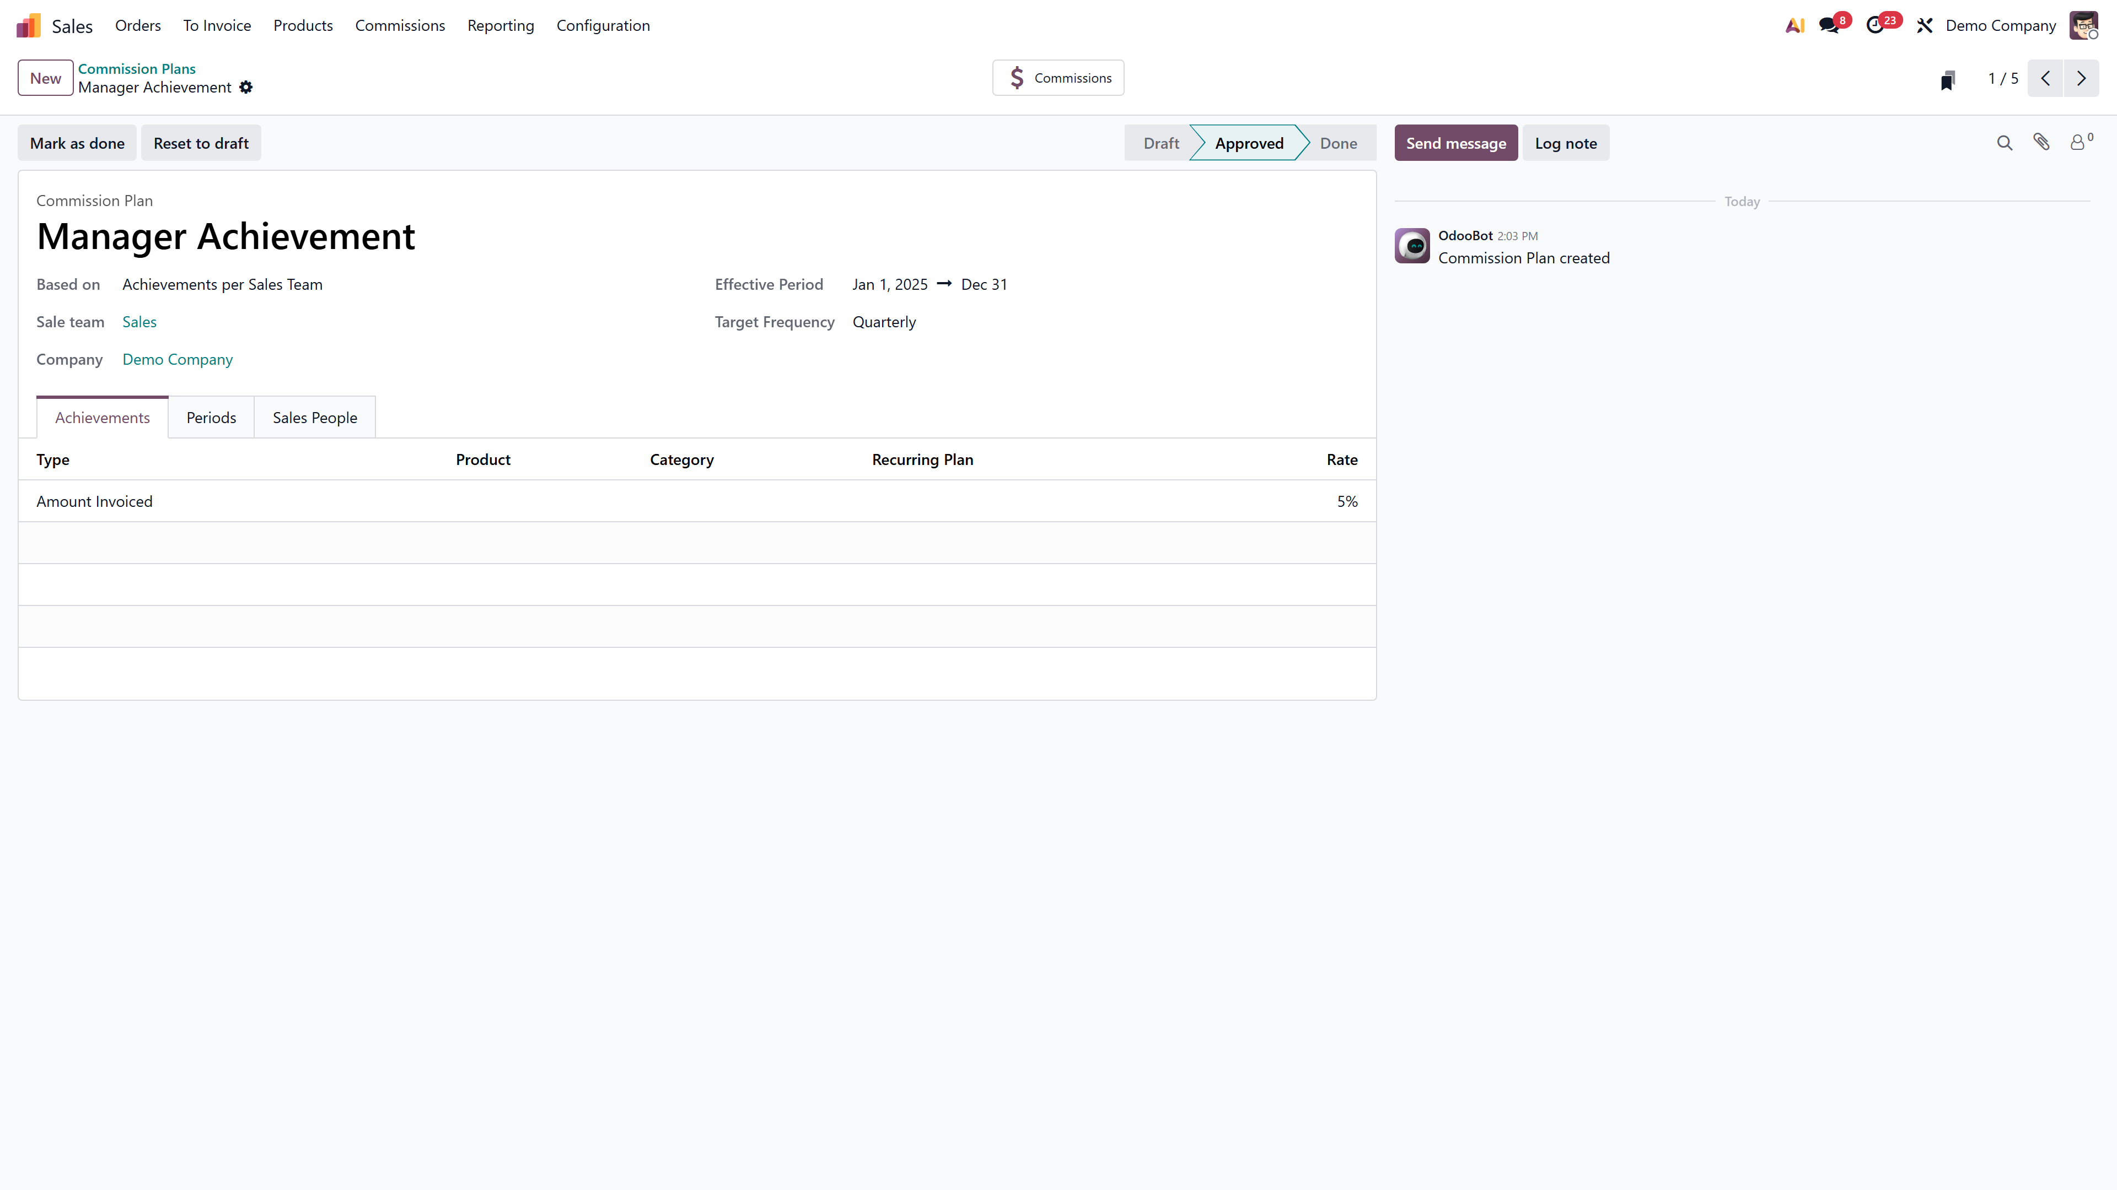
Commission Plan form with header fields

Tab 1: Periods
Odoo auto-generates periods based on your dates and periodicity:
- Monthly plan for 2026 → 12 monthly periods
- Quarterly plan for 2026 → 4 quarterly periods
- Yearly plan for FY 2026–27 → 1 annual period

Each period row shows:

Column | Description
Period | Auto-generated label (e.g., “2026 Q1”, “Jan 2026”)
From / To | Date range for the period
Amount | Sales target — enter manually
Payment Date | When commission is paid — defaults to period end
Payment Amount | (Read-only) Sum of amounts on same payment date

For target plans: Enter amounts per period. They can vary by season.
For achievement plans: Periods are generated but target amounts are optional.
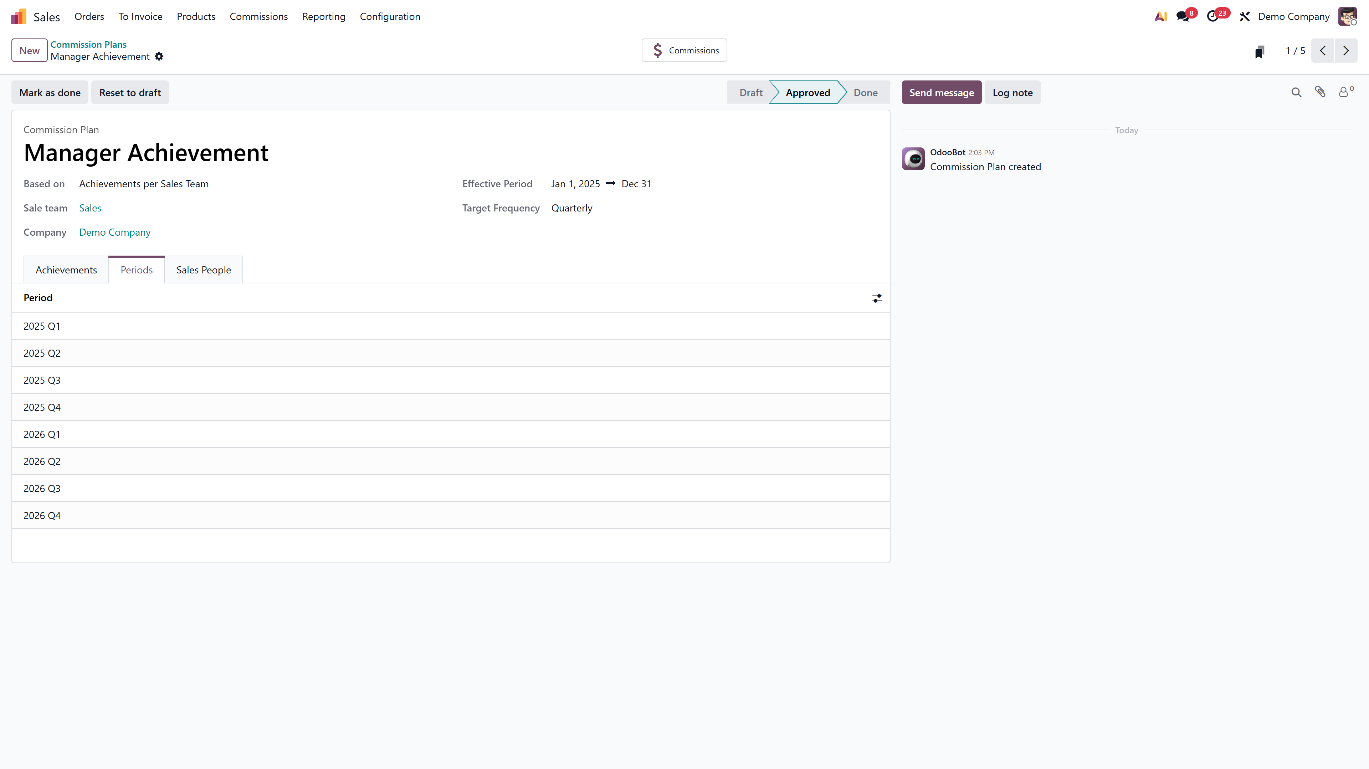
Periods tab showing quarterly target periods

Tab 2: Achievements
Click Add a new achievement to define what counts:

Achievement Type | What Gets Tracked
Amount Invoiced | Total ₹ value of confirmed invoices
Amount Sold | Total ₹ value of confirmed sales orders
Quantity Invoiced | Number of units on confirmed invoices
Quantity Sold | Number of units on confirmed sales orders

Additional fields per line:
- Rate — weight factor (default 5%). For a single metric, set to 1.0 for 100% weight.
- Product — filter to one specific product (optional)
- Category — filter to a product category (optional)
Multiple lines supported. Example: 60% on Amount Invoiced (rate 0.6) + 40% on Quantity Sold (rate 0.4).
ℹ️ Pro Tip: Leave Product and Category blank to track ALL products. Use filters for high-margin items or new product launches.
ℹ️ Extended Metrics: Sale Commission: Margin adds Margin. Sale Commission: Subscription adds MRR.

Achievements tab with achievement type and rate configuration

Tab 3: Commission Levels — Target Plans Only
Defines how commission scales with target achievement.
Default levels:

Target % | Commission | OTC Rate
0% | ₹0 | 0%
50% | ₹0 | 0%
100% | ₹50,000 | 100% of OTC

Recommended — add reward tiers:

Target % | Commission | What It Means
0% | ₹0 | No commission below threshold
50% | ₹15,000 | Partial reward for motivation
100% | ₹50,000 | Full On Target Commission
150% | ₹75,000 | 50% bonus for overperformance
200% | ₹1,00,000 | Double OTC for exceptional results

Odoo renders a live payout graph that updates as you edit levels.
ℹ️ Critical Rule: Without levels above 100%, a salesperson achieving 300% of target STILL only earns the 100% commission. Always add upper tiers.
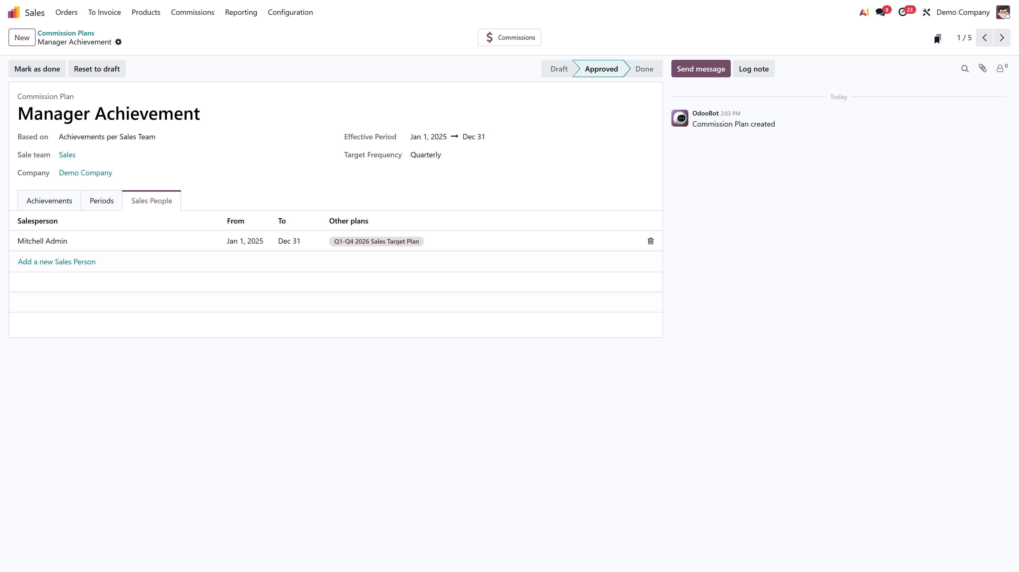
Commission plan with payout graph and levels

Tab 4: Sales People
- Add a new Sales Person — individual with optional From/To dates
- Add Multiple Salespersons — bulk wizard (Developer Mode required)
- Each row shows Other plans listing all active plans for that person

Sales People tab with assigned salespeople

Step 4: Approve the Plan
Click Approve to lock and begin automatic tracking.

State | What You Can Do
Draft | Edit everything freely
Approved | Locked. Click Reset to Draft to unlock.
Done | Period ended. Read-only record.
Cancelled | Deactivated. No further tracking.

How Commission Tracking Works Behind the Scenes
Once approved, Odoo automatically:
- Monitors every confirmed invoice/sales order by assigned salespeople
- Matches against achievement metrics (product/category filters)
- Aggregates totals per period
- Target plans: Achievement rate = (Achieved ÷ Target) × 100 → mapped to levels with linear interpolation
- Achievement plans: Commission = Achieved × Rate
- Displays results in reports
No cron job. No button to click. It just works.

Reading Commission Reports

Commissions View
📂 Sales → Commissions → Commissions
Shows per salesperson, per period: Achieved, Target Amount, Achieved Rate, Commission, Forecast, Payment Date, Notes.

Achievements Report
📂 Sales → Reporting → Commissions
Document-level detail: every invoice/sale order, customer name, commission rate, target period, and related document link.

My Commissions
📂 Sales → Commissions → My Commissions
Same as Commissions view, filtered to the logged-in user.
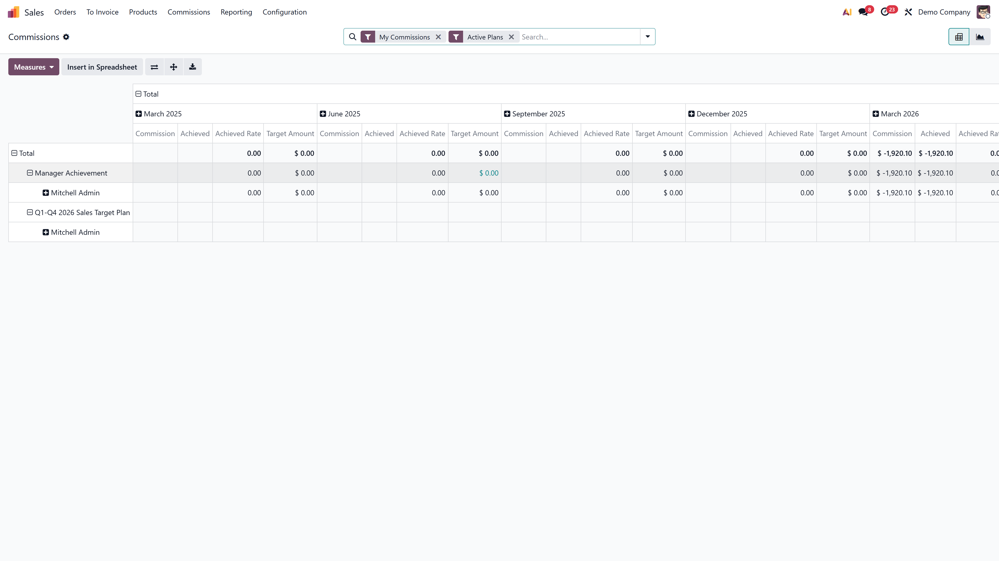
Commissions report showing achievements and payouts

Commission Adjustments
For edge cases — deal transfers, refunds, spot bonuses:

Scenario | Add to | Reduce From | Amount
Departing salesperson’s deal | New owner | Departing person | ₹2,50,000
Customer refund | — | Original salesperson | -₹50,000
Spot bonus for cross-sell | Salesperson | — | ₹25,000

Each adjustment records: achieved amount, add-to salesperson, reduce-from (optional), date, and descriptive note.

Payroll Connection
With HR Payroll installed, each plan gets a Payslip input field linked to payroll input types. Commission auto-populates in payslips.
End-to-end: Sales tracked → Commission calculated → Linked to payslip input → Payslip generated → Commission as salary component → Processed and paid

Indian SME Setup Example
Company: A Kochi-based electronics distributor with 8 field sales executives.
- Enable Commissions in Sales settings
- Create Plan: “FY 2026–27 Quarterly Sales Target” — Targets, Per Salesperson, Quarterly, Commission Amount ₹30,000
- Set Periods: Q1 ₹4,00,000 | Q2 ₹5,00,000 | Q3 ₹4,50,000 | Q4 ₹6,00,000
- Achievement: Amount Invoiced, Rate 1.0, All products
- Levels: 0%→₹0 | 50%→₹10,000 | 100%→₹30,000 | 150%→₹45,000 | 200%→₹60,000
- Assign all 8 salespeople via Add Multiple Salespersons (Developer Mode)
- Payslip input: Link to “Commission” input type
- Approve the plan

From this point, every invoice confirmation updates the achievement. At quarter-end, commission amounts are ready — in the report and in the payslip.

Frequently Asked Questions
Q1: Can I have both a target plan and an achievement plan for the same person?
Yes. Plans track independently. A salesperson can earn a flat 2% (achievement plan) plus a quarterly target bonus (target plan) simultaneously.
Q2: What metrics are available out of the box?
Amount Invoiced, Amount Sold, Quantity Invoiced, and Quantity Sold. With optional modules: Margin and MRR.
Q3: Can I commission only on specific product categories?
Yes. Set the Category field on the achievement line. Only matching invoices/orders will count.
Q4: Does the system handle partial-quarter hires?
Yes. Set a custom From date for the new hire in the Sales People tab. They’ll only be evaluated from that date.
Q5: How do commission levels interpolate between tiers?
Odoo uses linear interpolation. If levels are ₹0 at 50% and ₹50,000 at 100%, then 75% earns ₹25,000. The graph shows this visually.
Q6: Is commission data editable after approval?
Commission reports are calculated automatically and cannot be manually edited. Use Adjustments for corrections. The plan itself must be Reset to Draft for structural changes.

Ready to automate your sales commission process? Connect with the experts at Infintor for a hands-on Odoo 19 demo tailored to your business.

